**SYNCHORNIZATION HARDWARE**

Synchronization hardware i.e. hardware-based solution for the critical section problem which introduces the **hardware instructions** that can be used to resolve the critical section problem effectively. Hardware solutions are often easier and also improves the efficiency of the system.

There are three algorithms in the hardware approach of solving Process Synchronization problem:

1. Test and Set
2. Swap
3. Unlock and Lock

**Test and Set:**

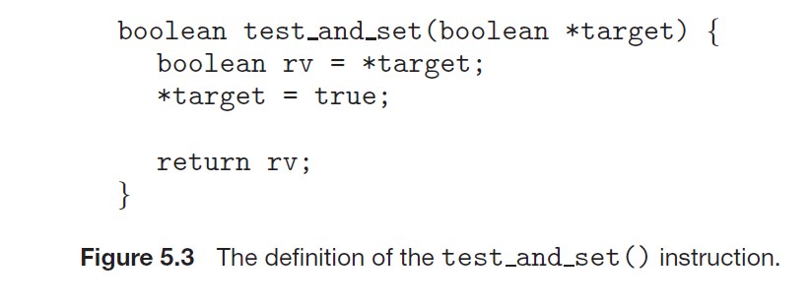

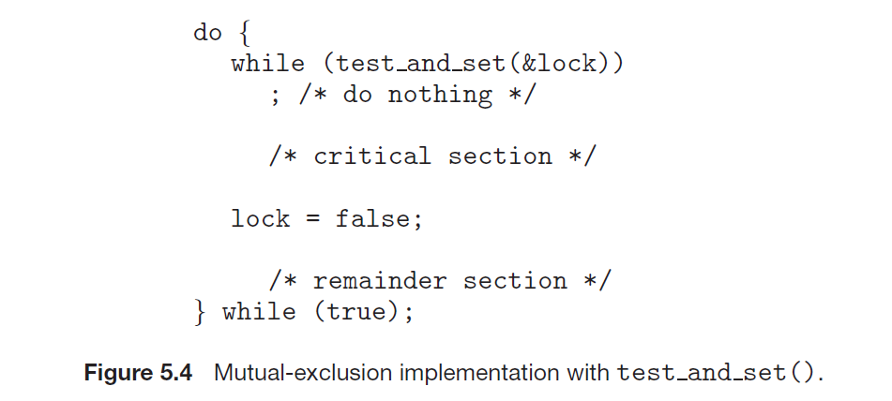

**Swap:**

// Shared variable lock initialized to false

// and individual key initialized to false;

Boolean lock,key=false;

void swap(boolean *a, boolean *b){

boolean temp = *a;

*a = *b;

*b = temp;

}

do

{

key = true;

while(key== true)

swap(&lock,&key);

**critical section**

lock = false;

**remainder section**

} while (true)

**Unlock and Lock:**

